**Tess Matlab Pack**

This document acts as a quick reference to the Tess distributable matlab pack allowing for the normalisation & alignment of embryo data from confocal & SORA imaging. This is **NOT** thorough documentation, rather something to flick back to as a refresher!

Overview of pack & its contents

This matlab pack contains 3 types of files:

* Class files (normalisedEmbryoData.m, normalisedSoraData.m)
  + Note: Will be referred to as NED and NSD from here on
* Graph files (generate…graphs….m)
* Protocol files (TessExample.m)

Protocol files are the types of files you will be using most as they instruct the framework, what to do. Within protocol files, you will enter parameters for your datasets as well as instructions as to what sort of graphs you want. Graphs can be made by calling the functions encoded by the graph files (see table). Finally, class files are little packages you will call to encode your datasets, essentially this allows each dataset to be treated as a separate entity that you supply to the graph files, which can then interpret it and do the rest for you.

|  |  |  |  |
| --- | --- | --- | --- |
| **File/Function name** | **What it does** | **What it needs** | **Example output** |
| generateProcessingGraphs | This function will generate a series of 6 graphs showing the steps processing and aligning the dataset from start to finish | A name & a single NED object |  |
| generateSDSEMGraphs | This function will overlay NED trends w/ SEM/SD shown with options for time amplitudal re-dimentionisation or not | A name & any amount of NED objects |  |
| generateSDSEMTNGraphs | As above, however will forcibly time normalise **between** datasets | A name & any amount of NED objects | See above – you can use your imagination or try it yourself xoxo |
| generateSDSEMTNGraphsSORA | As above, however for NSD data.  Amplitudal re-dimentionisation is not available due to the data being ratio driven | A name & any amount of NSD objects |  |
| generateSDSEMTNGraphsEVT | This function will overlay multiple NED **or** NSD trends with or without SEM or SD. Furthermore, this function will add coloured bands to denote the distribution of when events occur in each dataset | A name, any amount of NED or NSD objects (**Do not mix**), events to annotate, desired measure of spread |  |
| generateSDSEMTNUpDown | This function allows overlaying of a single NSD and NED track with SEM/SD | A name, a single NED object, a single NSD object |  |
| generateSDSEMTNUpDownEVT | This function allows the overlaying of a single NSD and NED with/without SEM/SD | A name, a single NED object, a single NSD object, events to annotate, measure of spread |  |

Note: most functions can be overloaded with alternate colour pallets as described here: <https://uk.mathworks.com/help/matlab/ref/colormap.html>

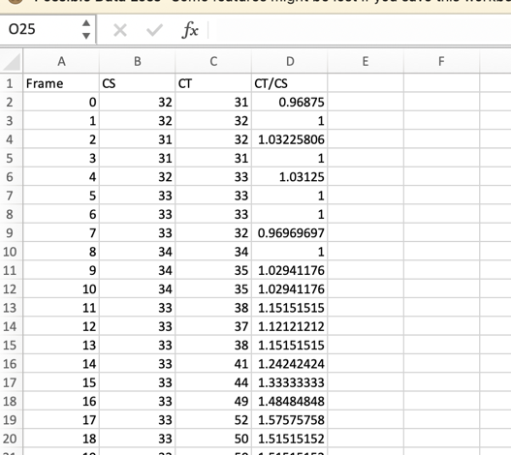What you need to get going:

NED data can be taken directly from the output of the trackmate datahandler. Note: do not use the compressed files as there is no need to throwaway data!

NSD data should be processed such that is formatted as left as a csv. (yes, this is hacky)

Note: Technically NED data can be composed of any X/Y frame/Value data where embryos give individual values per centriole. Similarly NSD data can be composed of any X/Y frame/value data where embryos give single values per frame (note this must be in column 4 cos hacky)

Taking you through the example! :3

Note: you can do a lot with this stuff, this example doesn’t include everything but it’s got a decent array, and most basically follows on or is similar.

Setting up custom colour maps:

* Encoded in the form [R1 G1 B1; R2 G2 B3;…]
* The second statement puts it in the form matlab prefers
* Graph files will then use the colours you specify sequentially
  + You MUST have equal to or more colours than data sets to plot

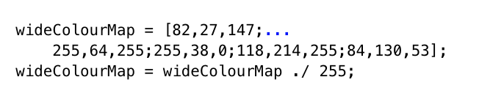

Setting up datasets:

* Get a base path for where the files are
* Set up an iteration array for the numbers at the end of the dataset
* Add corresponding lower bounds and upper bounds (in seconds!)
* *Optional:* add EVT cells to enable usage of the EVT graphs, again do this such that the order matches the Itt array!

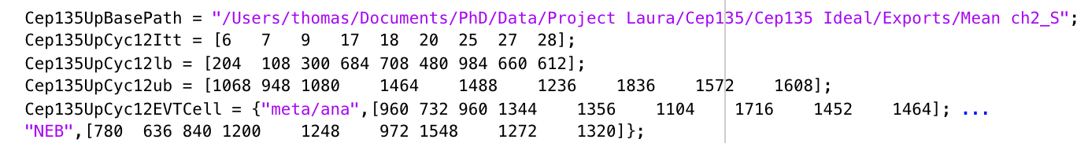

Take your data and shove it into NEDs/NSDs as shown below

* Note the order of parameters is important
* 3 averaging options are available for NEDs
  + “mean” – arithmetic mean
  + “median” – median
  + “meanPercentile95” – arithmetic mean of the middle 90% of data (Yeah, I realise I named this weirdly, and it annoys me too, BUT HERE WE ARE)

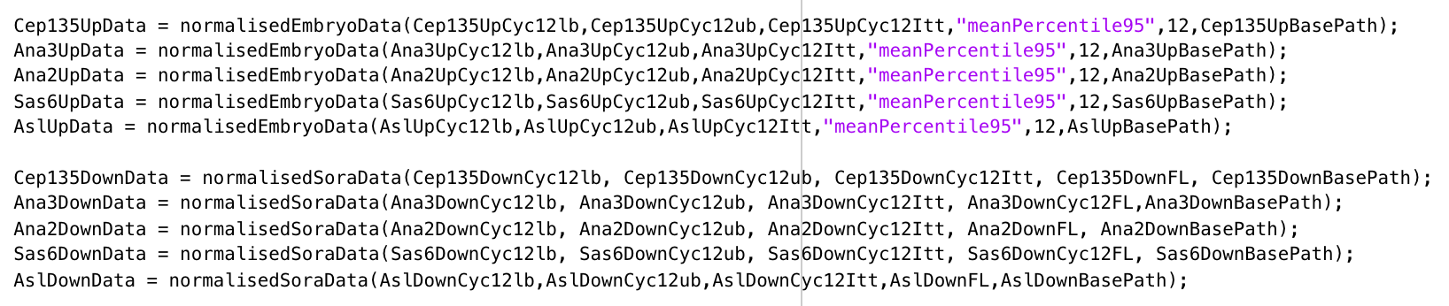

Add event timings to the data and setup an events to annotate if you want EVT graphs!

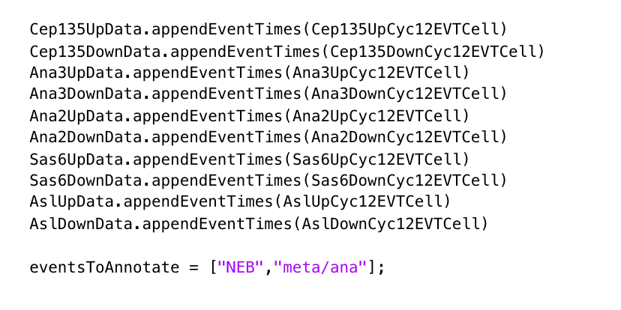

Get your graphs!

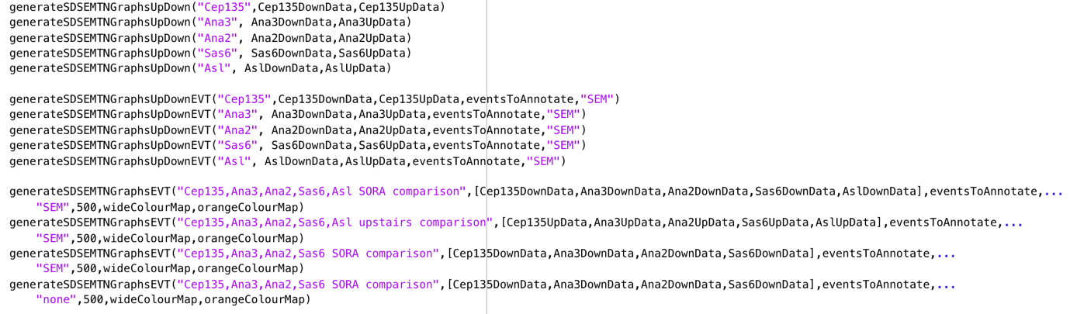

Et volia.

Note: with a lot of datasets it’ll take a hot minute so feel free to make a cup of tea/coffee <3